11 July 2022

Dear Resident

RE: Proposed new development at Alford Mews - Highgate

We would like to invite you to attend a public consultation event on proposals for the development of two new homes at Alford House Highgate, London.
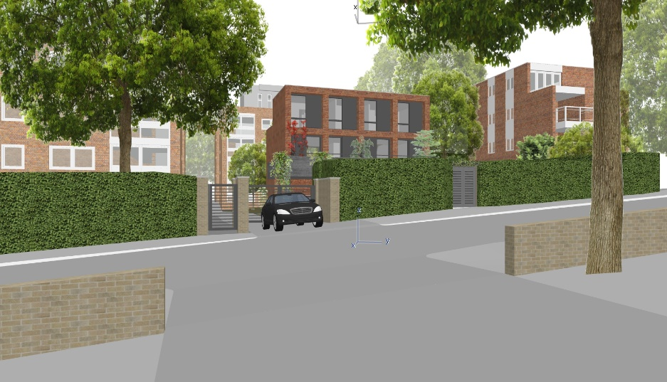

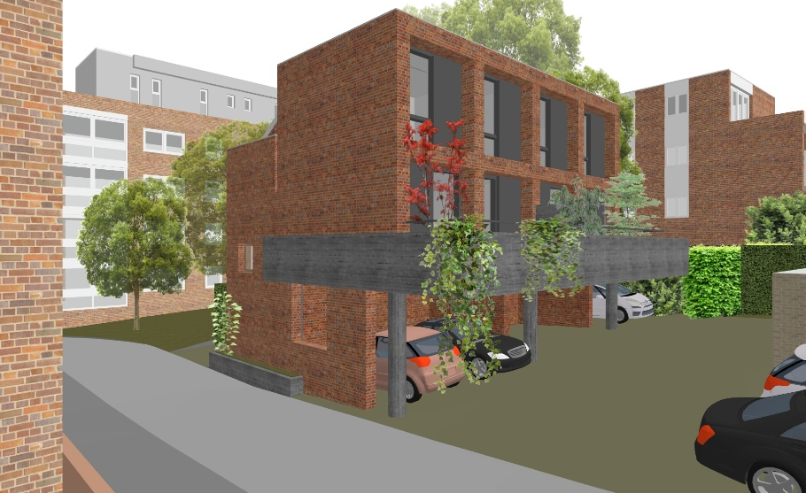
Figure 1 – External Plans
Source Erbar Mattes

We wish to consult with the local community before finalising the scheme and are planning a drop-in session to give residents an opportunity to view and comment on our initial proposals.

For your information, the details of the drop-in session are:

Date and Time: Wednesday 20th July 2:30 – 7:00pm
Venue: Jacksons Lane, Studio 5, 269a Archway Road, London N6 5AA

Representatives from the project team will be on hand to answer questions and there will be an opportunity to leave feedback.

If you are unable to attend the consultation, full details of the proposal can be found on our website: https://www.urbanissta.co.uk/public-access/

Details will be available via this link from 9.00am on the 20th July - exhibition day.

We would also be grateful if you could fill out the online questionnaire, which will be available on the above link.

We hope you can attend, and we look forward to meeting with you.

Yours Faithfully

A Hayward

Urbanissta
Planning Consultants acting on behalf of LonPro Highgate Ltd

